

**Trimester: I/II/III Subject: Programming and Problem Solving**

**Name**: Krishnaraj Thadesar **Division:** 9

**Roll No.:** 109054 **Batch:** I3

**Experiment No.:** 10

**Name of the Experiment:** Python program to sort n numbers.

**Performed on:** 28rd February 2022

**Submitted on:** 28st February 2022

**AIM**: Write a python program to accept n numbers and sort them in ascending and descending order

**OBJECTIVE:** To study sort and reverse function in python

**THEORY:**

**List:**

A list is a collection which is ordered and changeable. In Python lists are written with square brackets. The list is a most versatile datatype available in Python which can be written as a list of comma-separated values (items) between square brackets. Important thing about a list is that items in a list need not be of the same type.

**Sort():**

*sort()* is a inbuilt method in Python, it is used to sort the elements/objects of the list in Ascending and Descending Order. To sort a list in descending order, pass reverse=True as an argument with sort() method.

# PLATFORM: *Arch Linux 64 Bit with Python 3.10.1 from the AUR*

# ALGORITHM:

Step 1:Step 1: Take a list of n numbers from user

Step 2: Create a sorted copy of existing list using sort()

Step 3: Sort the List in Place

Step 4: print the List which is ascending order .

Step 5: Create a sorted copy of existing list

Step 6: Create sorted list in reverse order by setting reverse equal to True

Step 7: Print the List in descending order

Step 8: Stop

# Flowchart:

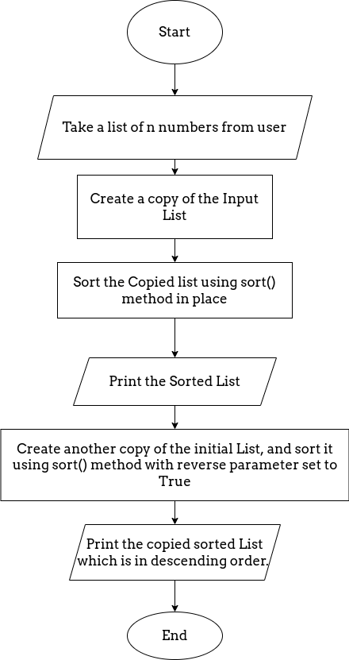

# CODE:

# Program to sort an array in python using default list sort function and then using

Bubble sort.

initial_list = []

limit = int(input("How many elements are there in the list?"))

for i in range(limit):

    val = int(input())

    initial_list.append(val)

ascending_list = initial_list[:]

print('Here is the Array sorted in Ascending order by default sort function')

ascending_list.sort()

print(ascending_list)

descending_list = initial_list[:]

print('Here is the Array sorted in Descending order by default sort function')

descending_list.sort(reverse=True)

print(descending_list)

**OUTPUT**

How many elements are there in the list? 5

2

1

45

2

1

Here is the Array sorted in Ascending order by default sort function

[1, 1, 2, 2, 45]

Here is the Array sorted in Descending order by default sort function

[45, 2, 2, 1, 1]

**CONCLUSION:**

Thus understood the concept of inbuilt function sort and reverse

**FAQs:**

1. **What is a List**

**Ans**: A list is **a data structure in Python that is a mutable, or changeable, ordered sequence of elements**. Each element or value that is inside of a list is called an item. Just as strings are defined as characters between quotes, lists are defined by having values between square brackets [ ]

1. **Explain sort()**

**Ans**: The sort() method is **a built-in Python method that, by default, sorts the list in ascending order**. However, you can modify the order from ascending to descending by specifying the sorting criteria.

1. **Explain reverse()**

**Ans**:Python List reverse() is an inbuilt method in the Python programming language that **reverses objects of the List in place**.

Syntax: list_name.reverse()

1. **What are different methods available in python ?**

**Ans:** Generally, there are three types of methods in Python:

1. Instance Methods.
2. Class Methods
3. *Static Methods*